Modulation of French WEEE EPR fees
Proposals for the period 2023-2027
Introduction
In 2010, France was the first country in the European Union (EU) to introduce a system for modulating EPR fees on waste electrical and electronic equipment (WEEE) with bonuses and maluses based on environmental criteria. This modulation aims to encourage producers to adopt virtuous practices for the equipment they put on the market.

This system is also intended to be deployed in the other EU Member States, since Article 8a of the Waste Framework Directive requires Member States to implement their own system by 5 January 2023 at the latest. In France, in application of law n° 2020-105 of 10 February 2020 against waste and for the circular economy (“AGEC”), modulation is intended to be extended to all Extended Producer Responsibility (EPR) systems, in addition to other measures such as repairability and durability indexes (2024) and consumer information on the environmental characteristics of products .

Through the requirements of the “AGEC” law and the accreditation requirements for EPR schemes, the public authorities ask the EPR schemes to propose, within 6 months after their accreditation, premiums and penalties based on relevant environmental performance criteria covering at least the following four criteria
- Repairability index or, where it is not defined, the availability of spare parts;
- Recyclability ;
- The presence of hazardous substances;
- The incorporation of recycled material;

These proposals will be presented for advice to the Stakeholder Committees of the EPR schemes, and then to the General Directorate for Risk Prevention (DGPR) of the Ministry of Ecological Transition for final validation.

Purpose of this document
In order to draw up these proposals, Ecologic and ecosystem EPR schemes wished to organise a joint consultation work with stakeholders. Following a phase of analysis of existing modulation and interviews with voluntary actors, this working document has been drawn up to submit proposals to stakeholders. This document is accompanied by a commenting form, which stakeholders are invited to use to return their opinions and comments, by 25 May 2022 at the latest, to
Thomas Van Nieuwenhuyse (assisting Ecologic and ecosystem)
thomas.vn@rudologia.fr

Summary of proposals
PRODUCT SCOPE
- Household equipment: [PER-MEN]: update modulated products scope and extend to targeted products to progressively reach 75% coverage of the placing on the market (POM).
- Professional equipment: [PER-PRO]: align the scope with the 6 new categories (i.e. add ex-categories 12, 13, 14 for some criteria), and provide for a review in 2024.
CRITERIA
Repairability index, or if not existing, spare parts availability
- Household equipment covered by the 1st wave of reparability indexes [REP-MEN-A-1]: malus for the 10-20% of EEE with the lowest repairability indexes of their category in 2023-2024, with a review in 2024 to switch at the earliest in 2025 to a modulation based on the durability index
OR: [REP-MEN-A-1]: malus for the 10-20% of EEE with low scores on criteria 1-2-3 of the repairability index in 2023-2024, to be replaced by the sustainability index in 2025 at the earliest
- Household equipment covered by the 2nd wave of repairability indexes [REP-MEN-B]: review in 2023 (N+1 after deployment of the indexes) to establish the thresholds applicable from 2024 onwards, on the same model as for products covered in the 1st wave
- Household equipment not covered by an index [EPR-MEN-C]: malus if documentation and spare parts are not available (extended to a wider range of products from 2025 onwards)
- Professional equipment [REP-PRO]: extend the current criteria for availability of spare parts, with a review in 2024 to update them if necessary
Recyclability
- Household equipment :
[REC-MEN-A]: malus if no visible marking available on the device indicating the presence of a lithium battery [REC-MEN-B]: malus if a lithium battery cannot be separated from the rest of the product
[REC-MEN-C]: malus if the mass of disruptive or non-recyclable materials ≥ 50% product mass
- Professional equipment :
[REC-PRO-A]: malus if no visible marking available on the device indicating the presence of a lithium battery [REC-PRO-B]: malus if a lithium battery cannot be separated from the rest of the product

Presence of hazardous substances
- Lamps [SUB-LAM-1]: bonus in case of LED source only, before updating the criteria
- Large household appliances integrating a heat pump [SUB-GEM]: malus in of presence of HFC gas
- Other household equipment:
[SUB-MEN-A]: from 2025 onwards, bonus if concentration of a list of hazardous substances is limited below a certain threshold
OR [SUB-MEN-B]: malus in case of presence of BFRs, with a review in 2024 for a possible revision
- Professional equipment [CR-PRO-3]: bonus in case of absence of BFR, with a review in 2024 for a possible revision
Incorporation of recycled materials
- Household and professional equipment [PLA-MEN-A] and [PLA-PRO-A]: bonus if the product incorporates at least 10% post-consumer recycled plastics (as a proportion of the total mass of plastic parts, excluding packaging)
- PRODUCT SCOPE

Household equipment
The proposal aims to broaden and better distribute the incentives on products with a high leverage effect for the sector, with the objective of progressively extending modulation to 75% of the products placed on the market in tonnages (compared to around 40% currently) by adding targeted products, taking into account the products newly covered by the repairability index and the Eco-design regulations, and adapting to the new challenges for the sector.
Proposal no. | [PER-MEN]
Products concerned | Household EEE
Modulated perimeter  from 2023 | Prolonging products already modulated: refrigerator, freezer (including combi), dishwasher, washing machine, hoover, coffee maker, kettle, tea maker, computer (desktop or laptop), tablet, TV, printer, mobile phone-smartphone, lamp, drill-driver, games console  Extension to associated products: wine cellar, tumble dryer, washing machine dryer, monitor, electric lawn mower
Review year | 2024
Further development | Extend modulation to new products in 2025 to cover 75% of POM, for example :  - Large cooking equipment: oven, electric cooker, hob and combined appliances  - Small food preparation equipment (toasters, mixers, food processors, etc.) and microwaves  - Water heater, boiler  - Air conditioner  - Small portable electronic, audio and video devices, camera, video camera, lights, mobility equipment  - Toys (electric trains, musical toys, drones, etc.)  - Personal care equipment (toothbrushes, razors, etc.)  - Household tools (high pressure cleaner, power tools not previously included)

Professional equipment
Given the limited feedback from the first year of declarations and the fact that the system is still in the process of being adopted, the proposal aims to extend the system to products in the former categories 12, 13 and 14, which have not been included until now.
Proposal no. | [PER-PRO]
Products concerned | Professional EEE
Modulated perimeter  from 2023 | Prolonging of products already modulated on the availability of spare parts.  Extension of modulation on recyclability, presence of hazardous substances and integration of recycled plastics to those products in former categories 12, 13 and 14 which were not included until now (since 1 January 2022, modulation has been extended to storage and conversion equipment)
Review year | 2024
Further development | Revise the scope according to the needs identified after a new assessment, and according to possible revisions of Ecodesign regulations

MODULATION CRITERIA

Repairability index, or if not existing, spare parts availability

Household equipment covered by the 1st wave of repairability indexes
For equipment covered by a repairability index, two proposals are made below. In both cases, a malus would be applied to the products with the lowest performance. This approach is proposed with the following objectives:
- to control the impact of the modulation on the financing of the WEEE scheme: in the absence of an observatory on market distribution, there is very limited feedback to identify thresholds for allocating bonuses to the highest performance products, without risking a major imbalance in the financing of the schemes
- to select discriminating criteria: based on the limited data available, initial findings suggest that a significant proportion of the 'top end' of the market in terms of repairability scores is spread over a relatively narrow range. The selection of discriminating thresholds on high scores seems difficult at this stage.

The first proposal ([REP-MEN-A-1]) is to base modulation on the overall repairability score. The advantages cited by some stakeholders are: direct consistency with the scores given to consumers and with the overall method of assessment, as well as ease of access to evidence. On the other hand, this option imposes POMs reporting at the level of each unit reference, which could make reporting and monitoring processes more cumbersome, and includes criteria which calculation or effects in terms of purchasing power or waste reduction are still debated among stakeholders. The second proposal ([REP-MEN-A-2]) is to base modulation on the scores obtained on certain criteria of the repairability index (criteria 1-2-3). According to some stakeholders, this option would have the following advantages: it would allow to make POMs declarations at the level of product ranges, as these criteria are the most cross-cutting, which would limit the cumbersome nature of the declaration and control system; it would be based on the criteria that are centred on the technical characteristics of the products and the easiest to control; it would avoid increasing the cost of the most financially accessible products, which are somehow automatically given a lower score on criterion 4 of the index. The disadvantages cited relate to what is considered to be a more limited consistency with the scores communicated to consumers, the need to check the details of the scoring grids, and the difficulty of obtaining a consensus on not taking certain criteria into account.
Proposal no. | [REP-MEN-A-1]
Criteria applicable from 2023 | Washing machine front loading | Malus if index < X (value of X to be fixed to discriminate 10-20% of POM)
 | Laptop computer | Malus if index < X (value of X to be fixed to discriminate 10-20% of POM)
 | Mobile phone / smartphone | Malus if index < X (value of X to be fixed to discriminate 10-20% of POM)
 | Television | Malus if index < X (value of X to be fixed to discriminate 10-20% of POM)
 | Electric lawn mower | Malus if index < X (value of X to be fixed to discriminate 10-20% of POM)
Method of proof | scores provided by the manufacturers
Review year | 2024
Further development | As 2024 will be a transitional year during which the repairability indexes will be replaced by the new durability indexes, according to the AGEC law, it will be proposed to maintain modulation in 2024 on the basis of the same criteria and thresholds as in 2023, and to study their replacement, from 2025 onwards, by a modulation based on the durability index. In parallel, a watch will have to be kept on the appearance of possible European indexes/Ecodesign regulations, in order to adapt the criteria if necessary.
OR
Proposal no. | [REP-MEN-A-2]
Criteria applicable from 2023 | Washing machine front loading | Malus if ∑ (criterion 1 + criterion 2 + criterion 3) < X (value of X to be set to discriminate 10- 20% of POM)
 | Laptop computer | Malus if ∑ (criterion 1 + criterion 2 + criterion 3) < X (value of X to be set to discriminate 10- 20% of POM)
 | Mobile phone / smartphone | Malus if ∑ (criterion 1 + criterion 2 + criterion 3) < X (value of X to be set to discriminate 10- 20% of POM)
 | Television | Malus if ∑ (criterion 1 + criterion 2 + criterion 3) < X (value of X to be set to discriminate 10- 20% of POM)
 | Electric lawn mower | Malus if ∑ (criterion 1 + criterion 2 + criterion 3) < X (value of X to be set to discriminate 10- 20% of POM)
Method of proof | scoring grids provided by the manufacturers
Review year | 2024
Further development | As 2024 will be a transitional year during which the repairability indexes will be replaced by the new durability indexes, according to the AGEC law, it will be proposed to maintain modulation in 2024 on the basis of the same criteria and thresholds as in 2023, and to study their replacement, from 2025 onwards, by a modulation based on the durability index. In parallel, a watch will have to be kept on the appearance of possible European indexes/Ecodesign regulations, in order to adapt the criteria if necessary.

Household equipment covered by the 2nd wave of repairability indexes
For equipment covered by the second wave of repairability indexes (whose deployment should start at the end of 2022, according to the latest available information), the proposal aims to adopt the same principle as for products covered by the 1st wave, leaving a minimum period of one year of implementation of the indexes before the application of the modulation criterion in order to have the necessary feedback for the setting of thresholds.
Proposal no. | [REP-MEN-B]
Criteria applicable from 2024 | Washing machine top loading | Malus based on the same rule as for the products covered by the 1st wave of indices
 | Dishwasher
 | Hoover
 | Tablet
 | High pressure cleaner
Method of proof | same methods of proof as for equipment covered by the 1st wave of indexes
Review year | 2023 to establish the criteria and thresholds applicable from 2024
Further development | For these products, the transition to the future durability indexes should rather be made by 2025. It will be proposed to maintain for one year after the entry into force of these durability indexes (a priori: until 2025 included at least) a modulation based on the same criteria and thresholds as those which came into force in 2024, then to study their replacement by a modulation based on the durability indexes. In parallel, a watch should be kept on the appearance of possible European indexes/Ecodesign regulations, in order to adapt the criteria if necessary.

Household equipment not covered by repairability indexes
For equipment not covered by repairability indexes, the proposal is to apply malus where there is insufficient or no availability of spare parts and documentation, in order to maintain consistency with the system adopted for products with indexes, and to allow for a smoother transition if such products were to be covered by repairability indexes.
Proposal no. | [REP-MEN-C]
Criteria applicable from 2023 | Coffee maker, tea maker, kettle | Malus in case of non-availability of spare parts essential to the use of the equipment and technical documentation
 | Desktop computer
 | Printer
 | Drill, screwdriver
Method of proof | continuation of current modes of proof
Review year | 2024
Further development | Extension envisaged to the following equipment from 2025: oven, cooker, hob and combined appliances, small food preparation equipment (toasters, mixers, food processors, etc.), microwave, water heater, boiler, air conditioner. In parallel, a watch should be kept on the appearance of possible European indexes/Ecodesign regulations, so that the criteria can be adapted if necessary.

Professional equipment
As feedback on professional equipment is still very limited, it is proposed to prolong the criteria, before reassessing them in 2024.
Proposal no. | [REP-PRO]
Criteria applicable from 2023 | Electronic displays | Bonus if spare parts essential to the use of the equipment are made available ≥ 10 years
 | Refrigerators with a direct sales function | Bonus if spare parts essential to the use of the equipment are made available ≥ 10 years
 | Professional refrigerators | Bonus if spare parts essential to the use of the equipment are made available ≥ 15 years
 | Welding equipment | Bonus if spare parts essential to the use of the equipment are made available ≥ 15 years
 | Imaging equipment | Bonus if spare parts essential to the use of the equipment are made available ≥ 6 years
 | Emergency lighting systems | Bonus if spare parts essential to the use of the equipment are made available ≥ 8 years
Method of proof | contractual documents committing to the provision of parts essential to the use of the equipment, for a period of time after the last unit of the model has been placed on the market
Review year | 2024
Further development | Review in 2024 to reassess thresholds. Updates as necessary according to possible revisions or creations of Eco-design regulations or NF / EN standards.

Recyclability

Household equipment
The proposals below consist in targeting the presence of recycling "disruptors" or non-recyclable materials in the WEEE stream. This approach is favoured in order to target operational issues for waste management operators, and taking into account the absence to date of standardised methods by product category allowing the calculation of recyclability indexes. The two proposals [REC-MEN-A] and [REC-MEN-B] aim to address the issue of the presence of lithium batteries in certain products. The proposed approach aims to distinguish, using two different criteria, between products for which the operational challenge is to identify the presence of batteries in order to be able to isolate these products from the rest of the stream, and products for which the operational challenge is to ensure that the battery can be easily removed in order to be able to recover the appliance. The products subject to one criteria or the other are determined according to the operational management of the different WEEE streams (smartphones, for example, being treated separately from the small household appliances, “SHA”) and their size (in the “SHA” stream, the very small size of certain objects containing lithium batteries will not allow them to be dismantled to extract the battery under current technical and economic conditions).
Proposal no. | [REC-MEN-A]
Applicable criteria  from 2023 | Tablet | Malus if no visible marking on the device indicating the presence of a lithium battery
 | Mobile phone, smartphone
Method of proof | product data sheet
Review year | 2024
Further development | Extension envisaged to the following equipment from 2025: small electronic devices (e.g. headphones, remote controls), portable audio and video (e.g. MP3, GPS), camera, camcorder, lights, toys (electric trains, musical toys, drones, etc.), personal care equipment (toothbrushes, razors, etc.)

Proposal no. | [REC-MEN-B]
Applicable criteria  from 2023 | Wireless hoover | Malus if a lithium battery cannot be separated from the rest of the product using standard screwdriver-type tools
 | Drill, screwdriver
 | Game console
Method of proof | Exploded view of the product allowing to identify how the battery is attached
Review year | 2024
Further development | Extension envisaged to the following equipment from 2025: small electronic devices (e.g. headphones, remote controls), portable audio and video (e.g. MP3, GPS), cameras, camcorders, lights, mobility equipment, toys (electric trains, musical toys, drones, etc.), personal care equipment (toothbrushes, razors, etc.), power tools

Proposal no. | [REC-MEN-C]
Applicable criteria  from 2023 | Washing machine (front and top loading) | Malus if mass of disruptive or non-recyclable materials (polyester, epoxy, all plastics with more than 5% glass fibre, carbon fibre, vegetable fibre) ≥ 50% product mass
 | Dishwasher
 | Corded hoover
 | Refrigerator, freezer, wine cellar
 | Tumble dryer, washer dryer
Method of proof | product nomenclature detailing the mass of the parts and their composition
Review year | 2024
Further development | Review in 2024 (N+1 after deployment of consumer information on product recyclability, according to Article 13 of the AGEC law) for possible alignment. Monitoring of possible European indexes/ Ecodesign regulations for adaptation of criteria if necessary.

Professional equipment
Given the diversity of professional equipment and their design constraints, and the absence to date of standardised methods by product category allowing the calculation of recyclability indexes, the proposals below consist in targeting the presence and ease of extraction of lithium batteries. The proposed approach aims to distinguish, using two different criteria, between products for which the operational challenge is to identify the presence of batteries in order to be able to isolate these products from the rest of the stream, and products for which the operational challenge is to identify the ease of extraction of the battery in order to be able to recover the appliance. The products subject to one criteria or the other are determined according to the operational management of the various WEEE flows and their size (the very small size of certain objects containing lithium batteries will not, for example, allow them to be dismantled to extract the battery under current technical and economic conditions).
Proposal no. | [REC-PRO-A]
Applicable criteria  from 2023 | Products requiring easy visual identification of the presence of lithium batteries  (list to be further defined) | Malus if no visible marking on the device indicating the presence of a lithium battery
Method of proof | product data sheet
Review year | 2024
Further development | Review in 2024 to adapt the criteria and target products if necessary.
Proposal no. | [REC-PRO-B]
Applicable criteria  from 2023 | Products requiring battery extraction before processing  (list to be further defined) | Malus if a lithium battery cannot be separated from the rest of the product using standard screwdriver-type tools
Method of proof | Exploded view of the product to identify how the battery is attached
Review year | 2024
Further development | Review in 2024 to adapt the criteria and target products if necessary.

Presence of hazardous substances

Lamps
Pending the outcome of the (ongoing) review of the EU mercury legislation, it is proposed to extend the current criterion before changing it if/when it becomes obsolete.
Proposal no. | [SUB-LAM]
Applicable criteria  from 2023 | Lamps | bonus in case of LED source only
Method of proof | technical data sheet
Review year | 2024
Further development | Monitor the revision of the European legislation on mercury (under public consultation until 3 May 2022) and replace the specific criterion for lamps as soon as it is obsolete by a criterion aligned with other equipment

Large household appliances using a heat pump
For tumble dryers and washing machines with integrated heat pumps, the main environmental issue is the type of gas used in the heat pump. The proposal therefore aims to prioritise this issue for these products.
Proposal no. | [SUB-GEM]
Applicable criteria  from 2023 | tumble dryers and washing machines with integrated heat pumps | malus in the case of presence of HFC gas
Method of proof | technical data sheet
Review year | 2025
Proposal no. | Monitoring of the evolution of the market and European regulations, to adapt the criteria if necessary

Other household equipment
For other household equipment, two proposals are presented below. The first proposal [SUB-MEN-A] consists in extending the scope of substances targeted in the framework of modulation beyond brominated flame retardants, with the aim of optimising the future circularity of materials, and avoiding encouraging substitution by other equally problematic substances. In this broader approach, taking into account the very changing regulatory context on the subject with the ongoing revision of the REACH regulation and the latest announcements of the European Commission (i.e. "Restrictions roadmap" presented at the end of April 2022), and in order not to introduce bonus or malus systems on substances whose use would be regulated in any case, it is proposed that the list of targeted substances and applicable thresholds be defined in 2024 for a potential entry into force from 2025. This proposal, intended to be more proactive, would then take the form of a bonus for products not containing the targeted substances. The second proposal [SUB-MEN-B] would be to maintain a modulation in the form of a malus for products containing brominated flame retardants in the short term, before revising this criterion in the light of future regulatory developments.
Proposal no. | [SUB-MEN-A]
Applicable criteria  from 2025 | Coffee maker, kettle, tea maker | Bonus if the concentration of a list of hazardous substances is limited below a certain threshold
 | Laptop and desktop computers
 | Television, monitor,
 | Tablet
 | Mobile phone, smartphone
 | Printer
 | Power tools
 | Game console
 | Electric lawn mower
 | Oven, electric cooker, hob, combined appliances
 | Small food preparation equipment, microwave
 | Small portable electronic, audio/video devices, camera, video camera
 | Lamps, lighting sources
 | Mobility equipment
 | Toys (electric trains, musical toys, drones, etc.)
 | Personal care equipment (toothbrushes, razors, etc.)
Methods of proof | - Evidence of obtaining a recognised label as a means of proof for the product concerned (to be defined, e.g. Blue Angel, EPEAT, TCO)  - Product test report carried out by an accredited laboratory in accordance with EN ISO/IEC 17025,  - or Material and Safety Data Sheet or certificates from the suppliers of the materials used for the whole product stating the absence of the substances concerned, accompanied by a nomenclature detailing the list of materials used in the product
Review year | 2024
Further development | Review in 2024 to specify the substances, thresholds and parts targeted, taking into account the revisions of applicable regulations in Europe
OR
Proposal no. | [SUB-MEN-B]
Applicable criteria  from 2023 | Coffee maker, kettle, tea maker | Malus if presence of brominated flame retardants in plastic parts > 25 g, except for cables and printed circuit boards
 | Laptop and desktop computers
 | Television, monitor
 | Tablet
 | Mobile phone, smartphone
 | Printer
 | Drill, screwdriver
 | Game console
 | Electric lawn mower
Methods of proof | - Evidence of obtaining a recognised label as a means of proof for the product concerned (to be defined, e.g. Blue Angel, EPEAT, TCO)  - Product test report carried out by an accredited laboratory in accordance with EN ISO/IEC 17025,  - or Material and Safety Data Sheet or certificates from the suppliers of the materials used for the whole product stating the absence of the substances concerned, accompanied by a nomenclature detailing the list of materials used in the product
Review year | 2024
Further development | Review in 2024 for :  - revision of the substances, thresholds and parts covered and the choice of a bonus or malus on this criterion, taking into account the revisions of applicable regulations in Europe  - a planned extension from 2025 onwards to: ovens, electric cookers, hobs, handsets, small food preparation equipment, microwaves, small portable electronic, audio/video devices, cameras, camcorders, lamps, lights, mobility equipment, toys, personal care equipment, power tools

Professional equipment
Given the recent nature of this criterion on professional equipment, it is proposed to extend it before considering its revision in 2024.
Proposal no. | [SUB-PRO]
Applicable criteria  from 2023 | Equipment in categories 1 to 6 that contains more than 20% plastics by mass of the equipment and plastics containing flame retardants | Bonus if the product does not contain brominated flame retardants in plastic parts > 25 g, except for cables and printed circuit boards
Methods of proof | - Product test report carried out by an accredited laboratory in accordance with EN ISO/IEC 17025,  - or Material and Safety Data Sheet or certificates from the suppliers of the materials used in the whole product stating the absence of the substances concerned, accompanied by a nomenclature listing the materials used in the product
Review year | 2024
Further development | Monitor the revision of the POP, RoHS and REACH regulations to adapt the criteria if necessary.

Incorporation of recycled materials
On this issue, the proposals aim to extend the scope of products eligible for a bonus on the integration of recycled plastics, and to exploit recent developments in traceability and certification systems to strengthen the control of this criterion under a "chain of custody" approach.

Household equipment
Proposal no. | [PLA-MEN-A]
Applicable criteria  from 2023 | Washing machine (front and top loading) | Bonus if the product incorporates at least 10% post-consumer recycled plastics (as a proportion of the total mass of plastic parts, excluding packaging)
 | Dishwasher
 | Coffee maker, kettle, tea maker
 | Laptop and desktop computers
 | Television, monitor
 | Printer
 | Wireless and corded hoover
Methods of proof | - Traceability of the origin and volumes of recycled materials purchased by the regenerator(s) and plastics manufacturer(s), according to the POLYREC, PolyCert Europe or IPC/LNE level 1 reporting systems.  - Certificate attesting to the recycled content of the materials used in manufacture in accordance with EN15343:2007: Recyclass (Europe or worldwide), UL2809 (Europe or worldwide), Plastica Seconda Vita (Italy), IPC/LNE level 2 (France)  - Calculation of the recycled content in the product according to EN45557.
Review year | 2025
Further development | Review in 2025 (N+1 after deployment of consumer information on the presence of recycled material in products) for adaptation of the criteria if necessary from 2026. Extension envisaged to the following equipment from 2025: high-pressure cleaners, small food preparation equipment, refrigerators, freezers, wine cellars, tumble dryers, washing machines, games consoles, small portable electronic devices, portable audio and video equipment, cameras, video camera, lighting, mobility equipment, toys, healthcare equipment

Professional equipment
Proposal no. | [PLA-PRO-A]
Applicable criteria  from 2023 | Equipment in categories 1 to 6 that contains ≥ 20% plastics by mass of the equipment | Bonus if the product incorporates at least 10% post-consumer recycled plastics (as a proportion of the total mass of plastic parts, excluding packaging)
Methods of proof | Same methods of proof as for household equipment
Review year | 2025
Further development | Review in 2025 to adapt criteria if necessary from 2026.
- AMPLITUDES AND MECHANISMS
The future mechanism for the application of the criteria and their cumulation rules will aim to simplify the application of the criteria when several criteria apply to the same product, and to improve the incentive of the system by removing the conditions between criteria.
The modulation amplitudes will be established taking into account the changes in the EPR fees levels planned for the various product categories and sub-categories in the coming years (it being expected that the financing of the Reuse, Preparation for Re-use and Repair Funds will significantly modify these amounts for a large proportion of products).
An initial large-scale assessment will be carried out on the economic impacts of the selected options, with a view to validating them and correctly calibrating the associated amplitude levels, with the aim of not jeopardising the financial equilibrium of the sector, whether
- with regard to the financing needs of the operations of the WEEE sector,
- with regard to the balancing of bonuses, malus and "neutral" scales within each product family,
- in terms of balancing between EPR schemes (the distribution of declarations of POMs being different, by product family, between EPR schemes)
A progressive approach over the coming years could be implemented, if necessary, in order to initially assess the positioning of declared products with regard to the new modulation criteria. A review after the first year of implementation of the criteria could also be proposed in the event that the financial equilibrium of the sector becomes destabilised.

ANNEX 1: Household EEE overview by products and criteria (subject to the options selected)
 | Repairability index or availability of parts |  |  | Recyclability |  |  | Hazardous substances |  |  | Integration of recycled plastics
 | malus |  |  | malus |  |  | bonus / malus |  |  | bonus
Products | 2023 | 2024 | 2025 | 2023 | 2024 | 2025 | 2023 | 2024 | 2025 | 2023 | 2024 | 2025
washing machine [frontload] (topload) without heat pump | [X] | (X) |  | X |  |  |  |  |  | X
washing machine [frontload] (topload) with heat pump | [X] | (X) |  |  |  |  | X |  |  | X
coffee maker, kettle, tea maker | X |  |  |  |  |  | X |  | X | X
laptop or desktop computer | X |  |  |  |  |  | X |  | X | X
television, monitor | X |  |  |  |  |  | X |  | X | X
mobile phone, smartphone | X |  |  | X |  |  | X |  | X
printer | X |  |  |  |  |  | X |  | X | X
drill/driver | X |  |  | X |  |  | X |  | X
electric lawnmower | X |  |  |  |  |  | X |  | X
tablet |  | X |  | X |  |  | X |  | X
dishwasher |  | X |  | X |  |  |  |  |  | X
wireless hoover |  | X |  | X |  |  |  |  |  | X
corded hoover |  | X |  | X |  |  |  |  |  | X
high-pressure cleaner |  | X |  |  |  |  |  |  |  |  |  | X
oven, electric cooker, hob, combined |  |  | X |  |  |  |  |  | X
water heater, boiler |  |  | X
air conditioner |  |  | X
small food preparation equipment |  |  | X |  |  |  |  |  | X |  |  | X
microwave |  |  | X |  |  |  |  |  | X
refrigerator, freezer, wine cellar |  |  |  | X |  |  |  |  |  |  |  | X
tumble dryer, washer dryer without heat pump |  |  |  | X |  |  |  |  |  |  |  | X
tumble dryer, washer dryer with heat pump |  |  |  |  |  |  | X |  |  |  |  | X
games console |  |  |  | X |  |  | X |  | X |  |  | X
small portable electronic, audio/video devices, camera |  |  |  |  |  | X |  |  | X |  |  | X
lighting sources |  |  |  |  |  | X |  |  | X |  |  | X
lamps |  |  |  |  |  |  | X
mobility facilities |  |  |  |  |  | X |  |  | X |  |  | X
toys (electric trains, musical toys, drones, etc.) |  |  |  |  |  | X |  |  | X |  |  | X
personal care equipment (toothbrushes, razors, etc.) |  |  |  |  |  | X |  |  | X |  |  | X
hand-held power tools |  |  |  |  |  | X |  |  | X
ANNEX 2: Household EEE overview by date of application (subject to the options selected)
2023
Repairability index or parts availability (malus) | Recyclability (malus) | Hazardous substances  (bonus or malus) | Integration of recycled plastics (bonus)
- frontloading washing machine  - coffee maker, kettle, tea maker  - desktop and laptop computers  - television, monitor  - mobile phone, smartphone  - printer  - drill/driver  - electric lawn mower | - laptop computer  - mobile phone, smartphone  - drill/driver  - tablet  - hoover  - games console  - washing machine, tumble dryer, washer dryer without heat pump | - lamps  - washing machine, tumble dryer, washer dryer with heat pump  - coffee maker, kettle, tea maker  - desktop and laptop computers  - television, monitor  - mobile phone, smartphone  - printer  - electric lawnmower  - tablet  - games console | - washing machine, tumble dryer, washer dryer  - coffee maker, kettle, tea maker  - desktop and laptop computers  - television, monitor  - printer  - drill/driver  - dishwasher  - hoover

2024 (additions)
Repairability index or parts availability (malus) | Recyclability (malus) | Hazardous substances  (bonus or malus) | Integration of recycled plastics (bonus)
- tablet
- washing machine top loading
- dishwasher
- hoover
- high-pressure cleaner

2025 (additions)
Repairability index or parts availability (malus) | Recyclability (malus) | Hazardous substances  (bonus or malus) | Integration of recycled plastics (bonus)
- oven, electric cooker, hob, combined appliances  - water heater, boiler  - air conditioner  - small food preparation equipment  - microwave | - refrigerator, freezer, wine cellar  - small portable electronic, audio and video devices, camera, video camera  - lighthing sources  - mobility facilities  - toys  - personal care equipment  - hand-held power tools | - hoover  - oven, electric cooker, hob, combined appliances  - small food preparation equipment  - microwave  - small portable electronic, audio and video devices, camera, video camera  - lighting sources  - mobility equipment  - toys  - personal care equipment  - hand-held power tools | - small food preparation equipment  - refrigerator, freezer, wine cellar  - games console  - small portable electronic, audio and video devices, camera, video camera  - lighint sources  - mobility equipment  - toys  - personal care equipment  - high pressure cleaner

APPENDIX 3: Professional EEE overview by products and criteria (subject to the options selected)
 | Repairability index or parts availability | Recyclability | Hazardous substances | Integration of recycled plastics
Products | bonus | malus | bonus | bonus
Electronic displays covered by REGULATION (EU) 2019/2021 | X
Refrigerators with a direct sales function covered by REGULATION (EU) 2019/2024 | X
Professional refrigerators referred to in Article 1(2)(a) of REGULATION (EU) 2019/2019 | X
Welding equipment covered by REGULATION (EU) 2019/1784 | X
Imaging equipment | X
Emergency lighting systems | X
Products requiring extraction from the battery before processing (to be further defined) |  | X
Products requiring identification of the presence of batteries (to be further defined) |  | X
Professional equipment in categories 1 to 6 that contains more than 20% plastics by mass of the equipment |  |  |  | X
Equipment in categories 1 to 6 that contains more than 20% plastics by mass of the equipment and plastics containing flame retardants |  |  | X

ANNEX 4: CONTROL PROCESS
Context
The use of the modulated fee scale is done at the time of the POM declaration. It assumes that the declarant is aware of the modulation criteria, their conditions of access and that he is able to justify them if he wishes to benefit from them. The registrant then uses the modulated code by ticking the box that specifies the criterion reached. The declarant must provide the EPR scheme with the documents enabling it to justify the use of this modulated scale at any time.
The request for communication of the supporting documents may be made at any time either by the EPR scheme or by a third party mandated by the EPR scheme within the framework of control audits.
If it is not possible to produce the evidence, the declaration must be re-established and corrected on the basis of the unmodulated scale, going back to the origin of the erroneous declarations and within a limit of 2 years.
Purpose of the control audit
It is carried out by a COFRAC-accredited third-party audit firm and takes place at the request of the EPR scheme as part of a general audit request covering all the declarations for the previous two years. It covers both the control of the quantities declared and the methodology used by the declarant, as well as the control of the existence of a written declaration procedure enabling a declaration rule to be established and, where applicable, its transmission to another declarant in the event that the main declarant is unable to perform. The general audits are governed by the accreditation requirements applicable to the EPR schemes and must cover a selection of members representing at least 20% of the quantities marketed by the EPR scheme.
The audit can also focus on a specific control point defined by the EPR scheme, such as the application of the modulation criteria. In the context of the revision of the modulation criteria, we propose an extension of this type of audit.
It will cover declarations that have applied modulated contributions and will aim to ensure that :
- the existence of evidence to access the modulation scale,
- the conformity and authenticity of the documents,
- that they are fully consistent with the eligibility criteria used,
- that they are perfectly in line with the criteria used at the time of the inspection and that they are in conformity with the date of the declaration.
Auditees will be chosen either randomly, objectively, on the basis of or selectively by the auditor and validated by the EPR schemes. The audited members will represent at least 15% of all modulated declarations.
Possible sanctions
In the case of declarations of ineligible equipment, a detailed report will inform the declarant of the errors made, or the failure to present compliant evidence.
The declarant will be asked to provide proof of the missing elements within two months of the notification. If he fails to do so, he will have to correct the invalidated declaration and pay the resulting full-rate contributions. In the event of clear proof of bad faith or intention to contravene or in the event of a repeat offence, the eco-organisation may impose sanctions:
- a mark-up of up to 50% of the full product contribution, applied to the number of products.
- a temporary suspension of its IDU,
- of its reporting to the DGPR.
Implications for EPR schemes
The implementation of such a system implies that the EPR schemes must implement additional means.
- Level 1 internal checks of incoming declarations.
- Specific level 2 controls by accredited auditors.
It will be possible through specific training of auditors on the modulation criteria and on the evidence to use the modulated declaration codes.

ANNEX 5: Reminder of current criteria

Household equipment
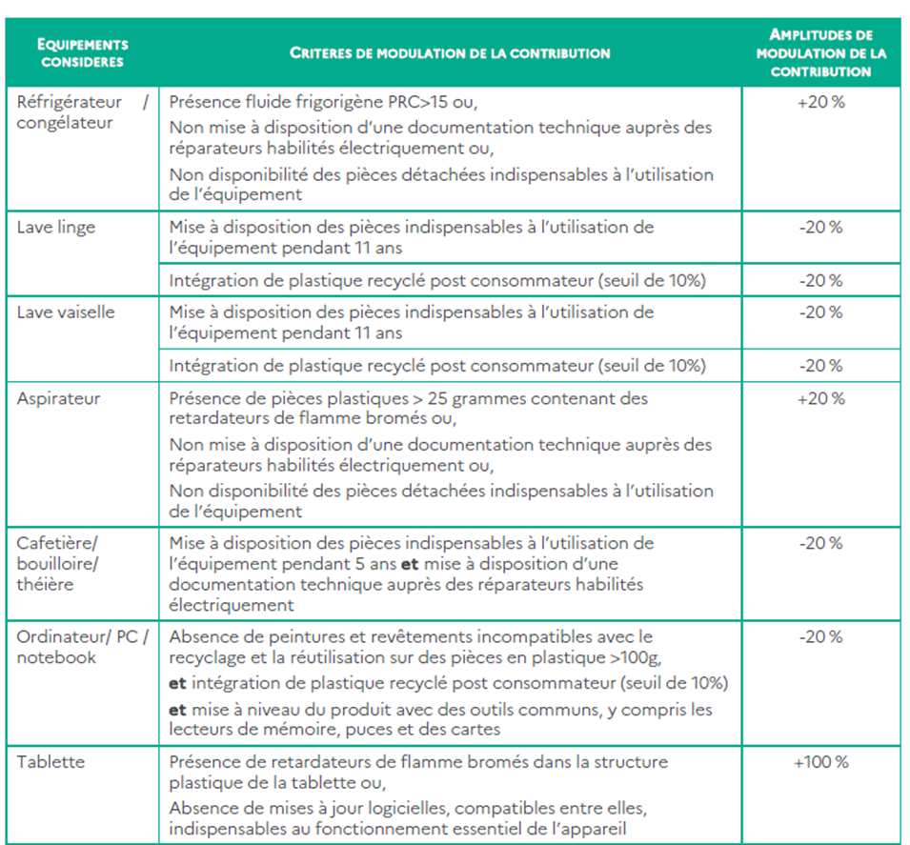
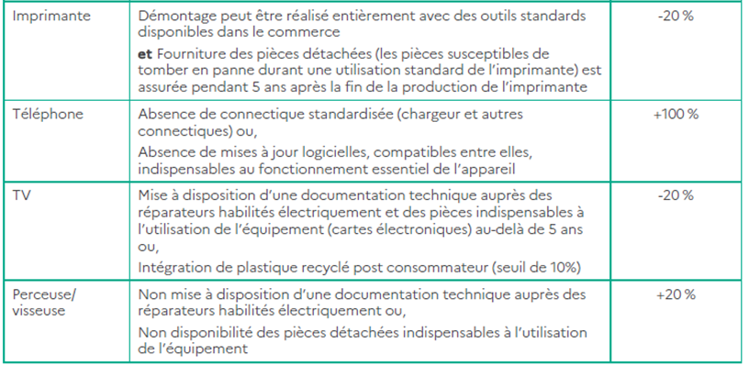
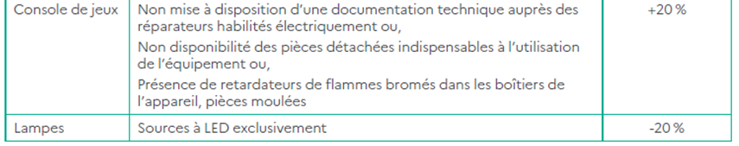

Professional equipment
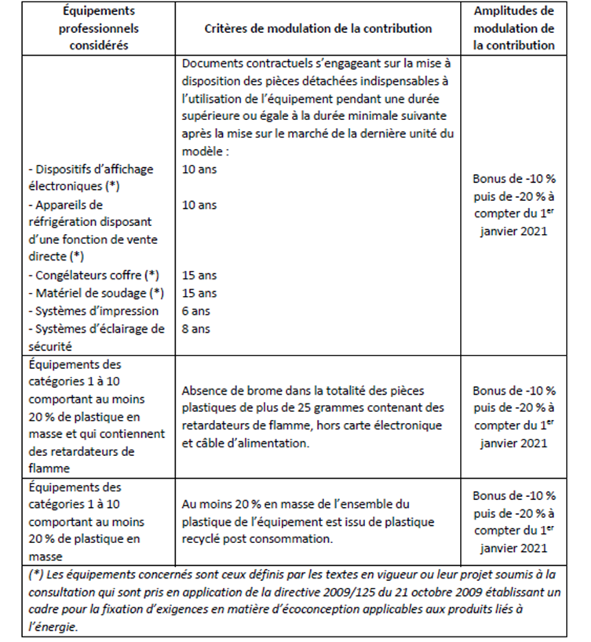
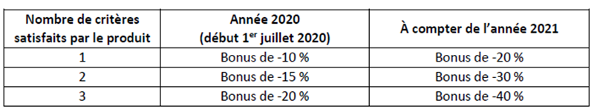

Article 13 of the “AGEC” law provides that (non-official translation) "producers and importers of products [...] shall inform consumers, by means of marking, labelling, display or any other appropriate process, about their environmental qualities and characteristics, in particular the incorporation of recycled material, the use of renewable resources, durability, compostability, reparability, reusability, recyclability and the presence of hazardous substances, precious metals or rare earths, in accordance with European Union law”.

