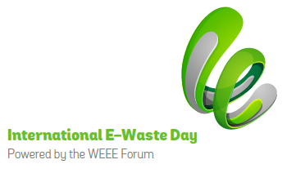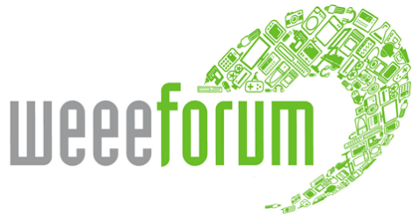

Brussels, 14 October 2020

Embargo: 07.00 GMT, Wednesday 14 October 2020

Third International E-Waste Day focuses on education to raise awareness of e-waste problem

Almost 100 organisations from 50 countries worldwide will take part in the third International E-Waste Day taking place on 14th October.

The event, organised by the WEEE Forum, an international association of non-profit and sector-mandated e-waste collection schemes, brings together e-waste stakeholders across the world to promote the correct treatment of waste electrical and electronic equipment to enable reuse and recycling. This year the emphasis will be on education and engaging with members of the public to increase awareness of the proper way to deal with their redundant electrical items.

It is estimated that 53.6 million tonnes of e-waste were generated across the planet in 2019, more than ever before, and this is projected to reach an incredible 75 million tonnes by 2030, which is 9 kg for every person in the world. E-waste is not only very prevalent it also has great value; the raw materials contained in the global e-waste generated in 2019 were worth approximately €50.8 billion.

Less than 18% of this global e-waste was officially documented as recycled last year, with the rest either placed in landfill, burned or illegally traded and treated in a sub-standard way and this is despite 71% of the world’s population being covered by e-waste legislation. This results in a huge loss of valuable and critical raw materials from the supply chain and causes serious health, environmental and societal issues.

Virginijus Sinkevičius, European Commissioner for Environment, Oceans and Fisheries expressed his support for the day “The Commission’s Circular Economy Action Plan takes circularity to the mainstream. The focus of the plan is on sectors where the impact is very high, such as electronics, and we will look at the whole lifecycle of products. At the top of the list is preventing waste generation – stopping it before it happens, and when it does happen, we look for ways to transform that waste into a useful resource. However, for this plan to be successful, we need citizens to be aware and know how they can contribute to a greener world. This is what makes International E-Waste Day so important and so relevant.”

Initiatives being undertaken by organisations participating in International E-Waste Day are designed to increase consumers’ knowledge about e-waste and how to dispose of it correctly so that reuse and repair options are optimised alongside recycling. Public and face to face events marking International E-Waste Day will be limited this year due to the ongoing coronavirus situation, but organisations are still taking the opportunity to highlight the work they are doing to improve e-waste management through online campaigns and events of reduced size.

For the occasion, the WEEE Forum has partnered with the International Telecommunication Union in drafting a report covering the rarely considered topic of Internet Waste (e-waste arising from Data Centres, 5G Connectivity infrastructure and the Internet of Things). In addition, to raise awareness among current and future generations of consumers, it has developed, among others, a short film featuring children from across the world presenting e-waste facts and urging people to pass on their e-waste.

Pascal Leroy, Director General of the WEEE Forum, said, “E-waste is the fastest growing domestic waste stream in the world, if we don’t continue to improve the way it is collected and treated it will continue to be a major environmental issue. One key area in the quest for continual improvement is in educating young people and the wider public; the more they know and understand, the more likely they are to make the correct decisions regarding their e-waste. This is the reason the 2020 edition of International E-Waste Day is dedicated to improving societal awareness.”

ENDS

Notes:

Further information on International E-Waste Day:
https://weee-forum.org/iewd-about/

International E-Waste Day visuals available for download:
https://www.dropbox.com/sh/ybqr9rfla42oqt0/AADfZ3Ed5sxzU7DVOgG6FfI_a?dl=0

Commissioner’s dedicated message and the video with children will be published on the below YouTube channel on 13 October:
https://www.youtube.com/channel/UC8KAjtQU2vSgcr7gevJ_hSg

Source for statistics quoted:
http://ewastemonitor.info/wp-content/uploads/2020/07/GEM_2020_def_july1_low.pdf#.

Contact for interviews:
Pascal Leroy
Director General, WEEE Forum
pascal.leroy@weee-forum.org
+32 473 75 61 53

WEEE Forum
The WEEE Forum, set up in 2002, is a Brussels-based international association speaking for 40 not-for-profit electrical and electronic equipment waste producer compliance schemes – alternatively referred to as ‘producer responsibility organisations’ (PRO). The 40 PROs are based across the globe in every continent except Antarctica. Together with its members, the WEEE Forum is at the forefront of turning the extended producer responsibility principle into an effective electronic waste management policy approach through combined knowledge of the technical, business and operational aspects of collection, logistics, de-pollution, processing, preparing for reuse and reporting of e-waste. Contact: info@weee-forum.org. Website: www.weee-forum.org

